
CONFIDENTIAL BUSINESS PLAN
[ Your Business Plan Title ]

[ Company Name ]

[ Your Company Logo ]
Prepared by [ Name ]
[ Month, Year ]
[ Email · Phone · Website ]

A free business-planning template from Leadership-Tools.com

Table of Contents
- Executive Summary
  - Highlights
  - Objectives
  - Mission Statement
  - Keys to Success

- Company Description
  - Company Ownership / Legal Entity
  - Market Analysis
  - Competitive Analysis

- Operations Structure
  - Location
  - Interior
  - Hours of Operation
  - Organizational Structure
  - Management Qualifications

- Service or Product Offer
  - Suppliers
  - Service
  - Manufacturing

- Marketing Strategy
  - Market Segmentation
  - Pricing
  - Advertising and Promotion

- Key Risks and Obstacles

- Goals and Strategy
  - Milestones
  - Sales Forecast
  - Break-Even Analysis
  - Strategy and Implementation

- Funding Request
  - Start-Up / Acquisition Summary
  - Start-Up Expenses
  - Determining Start-Up Capital

- Business Financials
  - Sales and Financial Management

- Appendix
  - Miscellaneous Documentation

This template is the companion to our free How to Write a Business Plan guide. Use it to build your plan section by section; for detailed instructions, examples, and tips on writing each part, see the guide. Both tools are available free at Leadership-Tools.com.
Executive Summary

 | It’s recommended that you complete this section of your business plan last. It will be easier to complete once you’ve already written your plan as you’ll be able to quickly summarize the most important points from your business plan.  Provide a concise and accurate description of your business, including goals and achievements to date. If your business is already established, describe what it set out to achieve; how it has accomplished goals to date, and what key objectives are next. If this is a new business, summarize your vision, how and when you intend to make this vision a reality, and how you will overcome any barriers to success.  Use the following subheadings to easily organize and present key sections of the executive summary.

Highlights

Summarize key business highlights. It’s also helpful to include charts or graphs to illustrate progress in sales, expenses and net profit over a period of multiple years.
Your Highlights:
Type your response here…

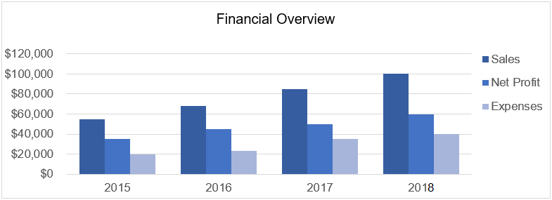

Objectives

Provide a brief timeline of the goals and objectives you plan to achieve related to your funding request. Keep it short and simple so the reader is clear on what you are working to accomplish.
Your Objectives:
Type your response here…

Mission Statement

Include the mission statement of your business here. Optionally, you may include background on the inspiration for the mission statement. Providing insight into what has motivated your mission statement can help to inspire the reader to adopt the mission. However, keep background information to a bare minimum.
Your Mission Statement:
Type your response here…

Keys to Success

Briefly describe unique or distinguishing factors that will help to ensure your business plan is successful. Factors might include personal experience or skills, new technology, industry trends and competitive advantage.
Your Keys to Success:
Type your response here…

Company Description

The company description section of your business plan provides an outline of key details about your business.
Important information includes the ownership and legal entity of the business. Additionally, you’ll provide a market analysis detailing where and how you’ll attract and grow your customer base. Also included is an analysis of the competitive environment.

Company Ownership / Legal Entity

State the type of your business. Is it a sole proprietorship, partnership or corporation (S or C)? In addition, define the industry of the business (such as financial services, manufacturing, merchandising, technology or service).
If your business is a franchise or an expansion of an existing business, share detail here.
If business licenses or permits are required, state whether these have been acquired. If not yet acquired, explain your plan for acquiring them and your current status in the process.
Your Company Ownership / Legal Entity:
Type your response here…

Market Analysis

Define the market that you focus on. What type of customer do hope to attract with your product or service? Include a detailed breakdown of your target customer by demographics. How large is your current client base, and how large could it be potentially with the right investment and leadership?
Where are these customers? How will you connect with them? How will know who and where you are, what you have to offer, and how buying from you will be of benefit?
If you believe that you have something new or innovative, how do you know there is a market for it? How have you determined the value and that customers will be willing to pay for what your business offers?
Consider your target market. What is currently taking place in the market. Is it expanding, getting smaller, staying the same? As a percentage, how big of an increase to your customer base do you believe is possible? How will you ensure market growth and lead your team to success?
Note: Include a chart or graph, such as the one below, to illustrate market growth opportunity.
Your Market Analysis:
Type your response here…

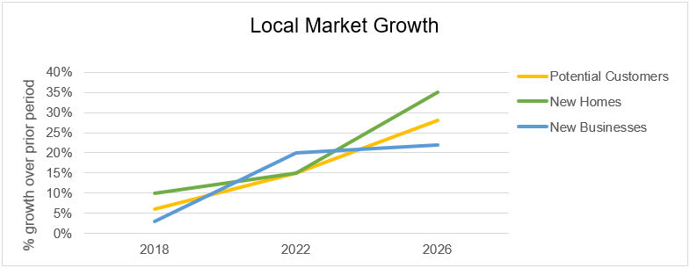

Competitive Analysis

Briefly describe your primary competitors. Provide the current composition of market share. What are the respective strengths and weaknesses of your competition?
Share insights on how they do business; how they approach product pricing, market advertising, and general marketing strategies. How do you intend for your business to be perceived as a greater value by customers, and how will this assist you in competing and winning a bigger share of the marketplace?
What other types of business channels will you compete with? For example, what about businesses selling online, big box stores or imports from overseas?
How will you stay on top of new technology, and effectively respond to industry changes that can impact future earnings? Let the reader know you have thoroughly researched the competitive landscape.
Your Competitive Analysis:
Type your response here…

Operations Structure

Share details on the benefits of your business location and overall facility. What are the hours of operation? Provide key information on the organizational structure of the facility. Identify the management team and share their qualifications to hold key leadership positions within the business. In each section, describe how the overall operations structure of your business creates value.

Location

The physical location of your business is critical for some business types, for instance local retail stores. Location is less important for businesses such as Internet companies.
• If your business is not as dependent on location, you may have an advantage, which should be explained here.
• If your location has been determined, provide details about how you made that decision. Outline the process you went through and the primary benefits the location provides to the future success of the business.
• If no location has been decided on, provide the process you intend to go through in making this important decision. Give the reader a strong sense that your approach is thoughtful and deliberate.
Examples of some key considerations might include, but are not limited to:
Define the size, type and location you’d like to buy or lease. Explain how each factor enhances the opportunity for growth of the business. Does the location need to be at street level or can it be in an office building or high-rise? When considering the needs of your employees and customers, should the location be in close proximity to public transportation?
When comparing potential locations for your business it’s important to consider access and traffic flow patterns. Is there adequate parking available? Does it have sufficient security in place? Do neighboring businesses compliment the type of customers who hope to attract?
Does the location provide opportunity for signage that will be highly visible to passing traffic? Are there local ordinances that limit signs in your area?
Your Location:
Type your response here…

Interior

The interior of your business may be as important as the exterior.
What is the amount of square feet your business requires? Will this amount of square footage allow for future expansion?
Identify requirements/modifications required for the space. Are these requirements allowed within your lease agreement?
Is the space attractive for displaying goods and provided services on-site? Describe how you intend to optimize the space. How will the flow of the interior contribute to a growth in sales?
Your Interior:
Type your response here…

Hours of Operation

Address your regular hours of operation. For instance, ”Open Monday – Friday 8am – 5pm; Saturday 9am – 4pm; Sunday Closed”. If you operate on any online channels (I.e., website) to service your customers 24/7/365, include this in your explanation.
Your Hours of Operation:
Type your response here…

Organizational Structure

This section defines how your business hierarchy will be organized. The organizational structure of your business can be illustrated by an organizational chart, outlining the various departments and lines of leadership.
For corporate entities, clearly indicate the names and titles for all key personnel, such as CEO, President, CFO, Director of Operations, Directory of Marketing, etc.
Sole proprietorships are easier since the number of employees will be small. However, if you outsource various elements of your team make this clear to the reader. For instance, do you work with a virtual assistant? Do you contract with freelancers for your website, marketing or graphic design needs? Although contract laborers do not have ownership in your business, they are responsible for critical aspects of the business so it’s important to show how and why you count on these third-party providers.
Your Organizational Structure:
Type your response here…

Management Qualifications

In this section you will provide greater detail on the experience and qualifications of your leadership team. First, explain your background and level of experience in this type of business. Explain what your role will be and how directly or indirectly you will be involved as an owner. If your intention is to lead through others, how will you oversee the activities of the business?
Describe other key personnel and their respective duties and responsibilities for growing the business. Include the following:
• Define each team member’s business qualifications and proven experience. (Resumes should be included in the Appendix section of this business plan.)
• What are the key skills and strengths each team member brings to the business?
• What area of performance is each team member responsible for and how will success be measured? (Job Descriptions can be included in the Appendix)
• Identify any skills that your team is lacking, which will require outside sourcing or additional hiring.
What training and support resources are available to employees? Do you have an employee handbook that details all company policies around performance and behavior? Will there be incentive plans and/or recognition programs to reward and recognize top performer in your business? If so, explain the key components of these plans and how they help to support the growth of your business.
If your business is a franchise, what type of assistance can you expect from the franchiser, and for how long? Include information about operating procedures and related guidance that has been provided to you by the franchiser.
Your Management Qualifications:
Type your response here…

Service or Product Offer

In this section you will provide details about your products or services and why they are of value to your customers. What makes your product or service uniquely qualified to attract new customers? Identify your potential market?
Explain what is included in your products or services. How did you decided on what will be included? Can you adjust the offer as needed to address future changes in the market?
If your business sells a product, what is your plan to control inventory levels? Are you suppliers or manufacturers reliable? How quickly is the product made once an order is placed? How will inventory be secured/protected?

Suppliers

Who are your suppliers? Have you already negotiated terms? If so, include details about the financial arrangement. If a supplier goes out of business do you have alternative suppliers?
Your Suppliers:
Type your response here…

Service

What are your plans to ensure that your business consistently delivers an outstanding customer experience? How will you teach and coach employees to deliver service to their customers? How do you monitor quality of service?
How will customer complaints be addressed? Will you ask for customer feedback on a regular basis? If so, how will this be done?
How do you make your service(s) rise above that of your primary competitors?
Your Service:
Type your response here…

Manufacturing

If your business manufactures a product(s), describe the process within the facility and any unique machinery or equipment that is required. However, DO NOT reveal any proprietary information unless the reader has signed a Non-Disclosure Agreement (NDA).
How will you deliver your products to market? Do you deliver directly to the customer (retail), or do you sell wholesale?
Your Manufacturing:
Type your response here…

Marketing Strategy

Your marketing approach is critical to growing a successful business. You must research the market landscape in its entirety to ensure your marketing dollars are spent effectively. Tell a story that provides proof that you’ve done your homework. Know who your ideal customer is; what they need and what they want. Have a clear plan to attract your target market consistently and effectively.

Market Segmentation
Remember, if you need help with any section? See the How to Write a Business Plan guide for step-by-step guidance.

Illustrate how your target market is segmented? What different levels of product or service will you offer to each segment and how will each offering differ in quality or price?
How is each market segment defined? For instance, are markets segmented by geographic area, product lines, pricing, or other criteria?
Which market segment is your primary target market? What percentage of the total market is this segment? What percentage of this segment will your business reach and how will profits from this segment compare to other segments?
Note: A pie chart like the example below is a good way to illustrate market segmentation.
Your Market Segmentation:
Type your response here…

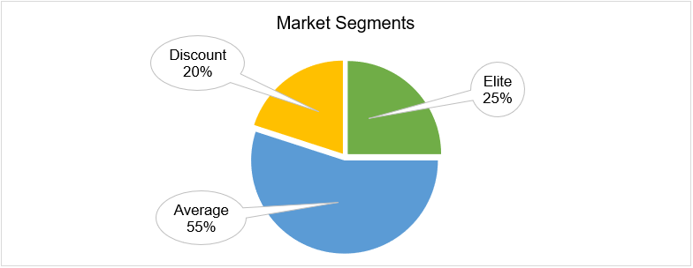

Pricing

Explain your approach to product or service pricing.
What is pricing strategy and how will your approach provide a competitive advantage? For instance, are you looking to price below the competition or above? How will you effectively justify your pricing to your target customers?
How will your pricing strategy compare with your primary competitors?
How will pricing be monitored as overhead expenses increase or decrease to ensure you protect your margin of profit? How will you stay current on new innovation and changes within the industry?

Your Pricing:
Type your response here…

Advertising and Promotion

How will you effectively advertise your business?
Explain in detail which advertising and promotion channels you will utilize to attract new customers. For example, will you leverage internet advertising, social media, traditional media (newspaper, magazine, television, radio), direct mail, seminars or workshops, other outside networking events, joint advertising with other companies, sales representatives, word-of-mouth, other?
To what extent will you advertise regularly on each channel and will you be conducting any seasonal campaigns?
What is your advertising budget and how will you track the results of your advertising and promotion investment?
Your Advertising and Promotion:
Type your response here…

Key Risks and Obstacles

In every business plan there are risks and every business leader should expect there to be obstacles, especially in the start-up phase of the business.
This section of your business plan should demonstrate to the reader that you are keenly aware of the risks involved and that you have thought through how you will handle risks and obstacles.
Your awareness of what could negatively impact the business is important as risk planning could be the difference between success and failure.
Contingency planning, also known as “what if” analysis, is highly valuable as it can assist you in minimizing the impact of unexpected barriers. As the business owner, you may need to make changes in your marketing strategies, operations and financial management to effectively respond when risks become a reality. Use this section to detail how you will guide your organization to overcome obstacles when they occur.
Your Key Risks and Obstacles:
Type your response here…

Goals and Strategy

In most business plans the goals section will focus primarily on sales targets and growth figures. However, goals can also help to demonstrate insight into what should be avoided, eliminated or reduced in order to maximize efficiency and profitability. To help develop goals that cover all the bases, consider using the ACES approach to goals setting:
Achieve: What do you want to attain in the future? I.e., increase sales, market share, brand awareness, etc.
Conserve: What do you want to retain? I.e., positive reputation, high service scores, customer and employee retention, etc.
Eliminate: What do you want to get rid of or reduce? I.e., overhead, old inventory, long-term debt, etc.
Steer clear: What do you want to avoid? I.e., losing competitive advantage, becoming obsolete in the industry, fines or fees, etc.

Milestones

This is a list of key objectives that your business will strive to achieve, by start and completion dates, and by budget. Milestones can easily be illustrated in a table or chart.
Your Milestones:
Type your response here…

Sales Forecast

Build your twelve-month sales forecast in the Business Plan Financial Workbook, then summarize the anticipated trend here, by month or quarter, alongside the related cost of sales.

Break-Even Analysis

Break-even is the point where your sales cover your costs and the business starts to turn a profit. The Business Plan Financial Workbook calculates the monthly sales you need to reach it from the numbers you enter. Run it, then state your break-even result here.

Strategy and Implementation

Here is where you will summarize your strategy for achieving your goals.
Now that you have described in prior sections the important elements of your business, you should summarize your strategy for implementation. If your business is new, prioritize the steps you must take to open your doors for business.
Describe your objectives and how each will support you in achieving your goals. Be as specific as you can, using timelines and graphs to illustrate your plan.
Strategic planning is the most important and overlooked part of your business plan to ensure that you are in control (as much as possible) of events and the direction in which your business is moving. Use this section to build confidence about your vision and leadership in the mind of the reader.
Your Strategy and Implementation:
Type your response here…

Funding Request

Clarify your funding request. Detail the amount of funding necessary to support your business. Explain how the funds will be used and specifically how you intend to repay the money, complete with all options for terms of repayment.

Start-Up / Acquisition Summary

Summarize key details concerning the starting or acquisition of your business. (If this is not applicable to your business, do not include this section.)
As noted in the preceding section, include your table of start-up or acquisition costs in the Appendix.
Your Start-Up / Acquisition Summary:
Type your response here…

Start-Up Expenses

List your one-time start-up costs in the Business Plan Financial Workbook. As you list each item, ask whether it’s a need-to-have upfront or a want-to-have you can add once the business is established. The workbook totals your costs and shows what it takes to open.

Determining Start-Up Capital

The workbook determines your start-up capital for you. It projects your cash month by month and flags the point where cash runs lowest, which is the amount you need to carry the business to break-even. Use the Business Plan Financial Workbook rather than working this out by hand.

Business Financials

This is where your plan meets the numbers. Enter your startup costs, your sales forecast, and your monthly expenses, and the workbook builds your Cash Flow Projection, Income Statement, and Balance Sheet from those inputs. It also tells you what it costs to open, the sales you need each month to break even, when cash runs short, and whether year one makes money.
A step-by-step tutorial walks you through it.
If you only need one statement on its own, each is also available as a standalone template: Balance Sheet, Income Statement, and Statement of Cash Flows.
When your numbers are complete, present the key results in this section or include the full statements in your Appendix.

Sales and Financial Management

Investors or bankers will be paying close attention to how you plan to manage the finances of your business. You’ll need to provide clarity to assure them you have what it takes to be a successful manager of the money they invest.
Given the products or services you plan to offer, how will you ensure your business is profitable and within what time period? Will your business provide you with a sufficient cash flow early on in the venture or will you have to be concerned with growing Accounts Receivable until sales catch up?
The full details of your start-up and operating costs can be included in the Appendix. However, you can reference appropriate tables, charts, or page numbers as you give a brief, summary accounting of your start-up needs and operating budget.
• Start-up costs will include any one-time only purchases, such as major equipment or supplies, down-payments, or deposits, as well as legal and professional fees, licenses/permits, insurance, renovation/design of your location, personnel costs prior to opening; advertising or promotion, etc.
• Once you open your business, you will need an operating budget to manage and prioritize expenses. It should include the money you need to survive the first three to six months of operation and indicate how you intend to control the finances of your business. Include the following expenses: rent, utilities, insurance, payroll (including taxes), loan payments, office supplies, travel and entertainment, legal and accounting, advertising and promotion, repairs and maintenance, depreciation, and any other categories specific to your business.
You can also include information (or cross-reference other sections of this business plan if covered elsewhere) about the type of accounting and inventory control system you are using, intend to use, or, where applicable, what the franchiser expects you to use.
Your ability to articulate a sales management solution and approach in your business plan is essential for winning over the reader. Your message should include:
- Explain in detail how you intend to drive sales. Sales management solutions can vary. Will you manage sales internally or by contracting with independent, commission-based representatives?
- Detail how you will recruit sales team candidates. How will you train your sales team? How do you intend to compensate sales staff? All of these questions need to be answered as part of your business plan.
- Explain how you have identified your prospects. How do you intend to market to prospective customers? How you will effectively ask for the business and what do you expect your success ratio will be.
Those who are reviewing your financial and sales management solutions and plans will be very interested in how you intend to lead sales activities, and what those activities will consist of, so take the time you need to clearly lay out your approach to managing finances and growing sales.

Appendix

Finally, we come to the appendix. A well-structured appendix provides additional documentation that supports your business plan. As you’ve completed the above sections of your business plan you’ve continually been advised to be brief and “keep it clear and simple”. However, you can’t assume the reader won’t want to dive into your plan in greater detail. Therefore, by including supporting materials in the appendix you can meet the expectations of every reader.
Providing a comprehensive appendix will add credibility to your plan and go a long way toward convincing your reader you’ve got a great business idea. Moreover, it will demonstrate to the reader that you’ve thoroughly thought through your plan.

Miscellaneous Documentation

Back up the statements made in prior sections of your business plan by including all supporting materials. For example, here are some of the documents you might consider including in your business plan appendix:
• Personal resumes
• Personal financial statements
• Credit reports, business and personal
• Copies of leases
• Letter of reference
• Relevant Contracts or Agreements
• Legal documents
• Personal and business tax returns
• Miscellaneous relevant documents.
• Photographs
Your Miscellaneous Documentation:
Type your response here…

Conclusion

Before writing your concluding statement, go back to the beginning to fine-tune and finalize the Executive Summary section of your business plan. Some will confuse the conclusion statement with the executive summary, but these are different.
The Executive Summary briefly explains what the reader is about to learn within the business plan.
The Conclusion is a brief statement from you to the person reading your business plan, which explains your passion, commitment and resolve to make the business successful. More importantly, you’ll explain how the reader will benefit by investing in your business, and by investing in you!
Your Conclusion:
Type your response here…

Wishing you all the best in your new business endeavor and leadership journey.

Richard Gorham
Founder, Leadership-Tools.com

