Life Balance Success Wheel
A practical self-check for living and leading in balance.
Clarity. Focus. Momentum. This tool turns six honest scores into one picture you can act on. Look at the shape, not just the numbers. A round-ish wheel rolls smoothly. A lopsided one tells you where the friction is.
Rate the parts of your life that matter most right now, plot them on the wheel, and let the shape show you where to focus first. Plan about fifteen minutes the first time. The point isn’t a perfectly round wheel. It’s spotting the one area that, raised by a single point, would make everything else easier.
Life has seasons, so some categories will run higher than others on purpose, and that’s fine. The goal is to catch what’s quietly becoming unsustainable and make one high-leverage change to create a smoother experience.
THE FIVE STEPS
Identify Your Top Six
Pick the six areas of life that matter most right now and name them so they fit your life, not someone else’s checklist. The category options on the next page give you a starting point if you want one.
Rate Your Satisfaction
Score each category 1 to 10 based on the past two to four weeks, not your best month or your worst day. Trust your first instinct. If you’re stuck between two numbers, pick the lower one. Honest scores beat aspirational ones.
Plot Your Wheel
Shade each wedge inward to your score. The shape tells you more than the numbers alone: where balance is strong, where it’s slipping, and where the friction lives.
Reflect on the Gaps
Find your lowest one or two scores and name the likely cause. Most low scores trace back to time, energy, boundaries, or systems. Knowing the cause points you to the right fix.
Commit to Action
Pick one focus category, not three. Choose one habit and one boundary you can hold for thirty days, and block two short windows on your calendar. Small, repeatable changes compound.
RATE HONESTLY (1 TO 10)
Score based on how the past few weeks felt, not how you wish they’d gone. A 10 isn’t perfect. It’s strong and sustainable for you right now.
9 – 10 | Strong and stable. This area would survive a stressful week.
7 – 8 | Good, but vulnerable. Under pressure, it’s the first thing that slips.
5 – 6 | Mixed. Some weeks fine, some weeks not. No clear pattern.
3 – 4 | Weak and affecting other areas. The gap is real and you feel it.
1 – 2 | Critical. Ignoring this longer will cost you.
CHOOSING YOUR SIX CATEGORIES
Start with familiar defaults, then make them yours. Rename anything that doesn’t fit (“Career” might become “Leading My Team”). Combine categories that overlap, add one your situation demands, then lock the list before you score. Adjusting categories mid-assessment usually means adjusting to make the picture look better.
Work / Career | Health / Energy
Relationships / Family | Finances
Personal Growth | Fun / Recovery
Faith / Purpose | Community / Home
YOUR WHEEL
Your Name |  |  |  | Date
WHY IT MATTERS · One sentence on what’s at stake right now
YOUR SIX CATEGORIES · Name each one, define a 9-10, then score it
# | Category Name |  | What a 9-10 Looks Like |  |  | Score (1-10)
1
2
3
4
5
6
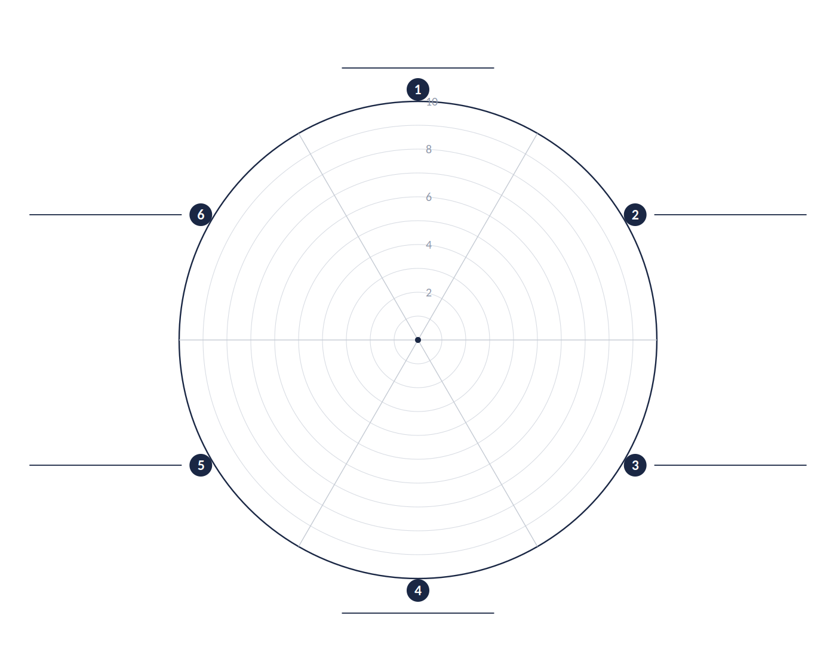
Write each category on its line, then shade each wedge inward to reflect your score.

REFLECT ON THE GAPS
Lowest score:
Likely cause:
Ripple effect:
COMMIT TO ACTION
Focus category:
One habit:
One boundary:
Calendar blocks:
COMPLETED EXAMPLE · Ben Carter, Operations Manager
Here’s a personal wheel filled in. Ben’s shape leans heavy toward Career and Family while Health and Friendships dip, so the lowest score is the obvious place to start.
Your Name |  | Ben Carter |  | Role | Operations Manager
WHY IT MATTERS
Work has been steady, but Health and Friendships have slid for months. Energy is dropping at home, and the team can feel it. Time to pick one and move it.
YOUR SIX CATEGORIES · Name each one, define a 9-10, then score it
# | Category Name |  | What a 9-10 Looks Like |  |  | Score (1-10)
1 | Family |  | Present 4+ nights/week, real conversations on weekends. |  |  | 7
2 | Health |  | Seven plus hours sleep most nights, movement 3x/week, steady energy. |  |  | 4
3 | Faith |  | Weekly practice that grounds me, not just a Sunday habit. |  |  | 6
4 | Friendships |  | One genuine catch-up per month with a close friend. |  |  | 5
5 | Finances |  | Bills covered, monthly savings on autopilot, low money stress. |  |  | 6
6 | Career |  | Proactive on priorities, end most days with a plan for tomorrow. |  |  | 7
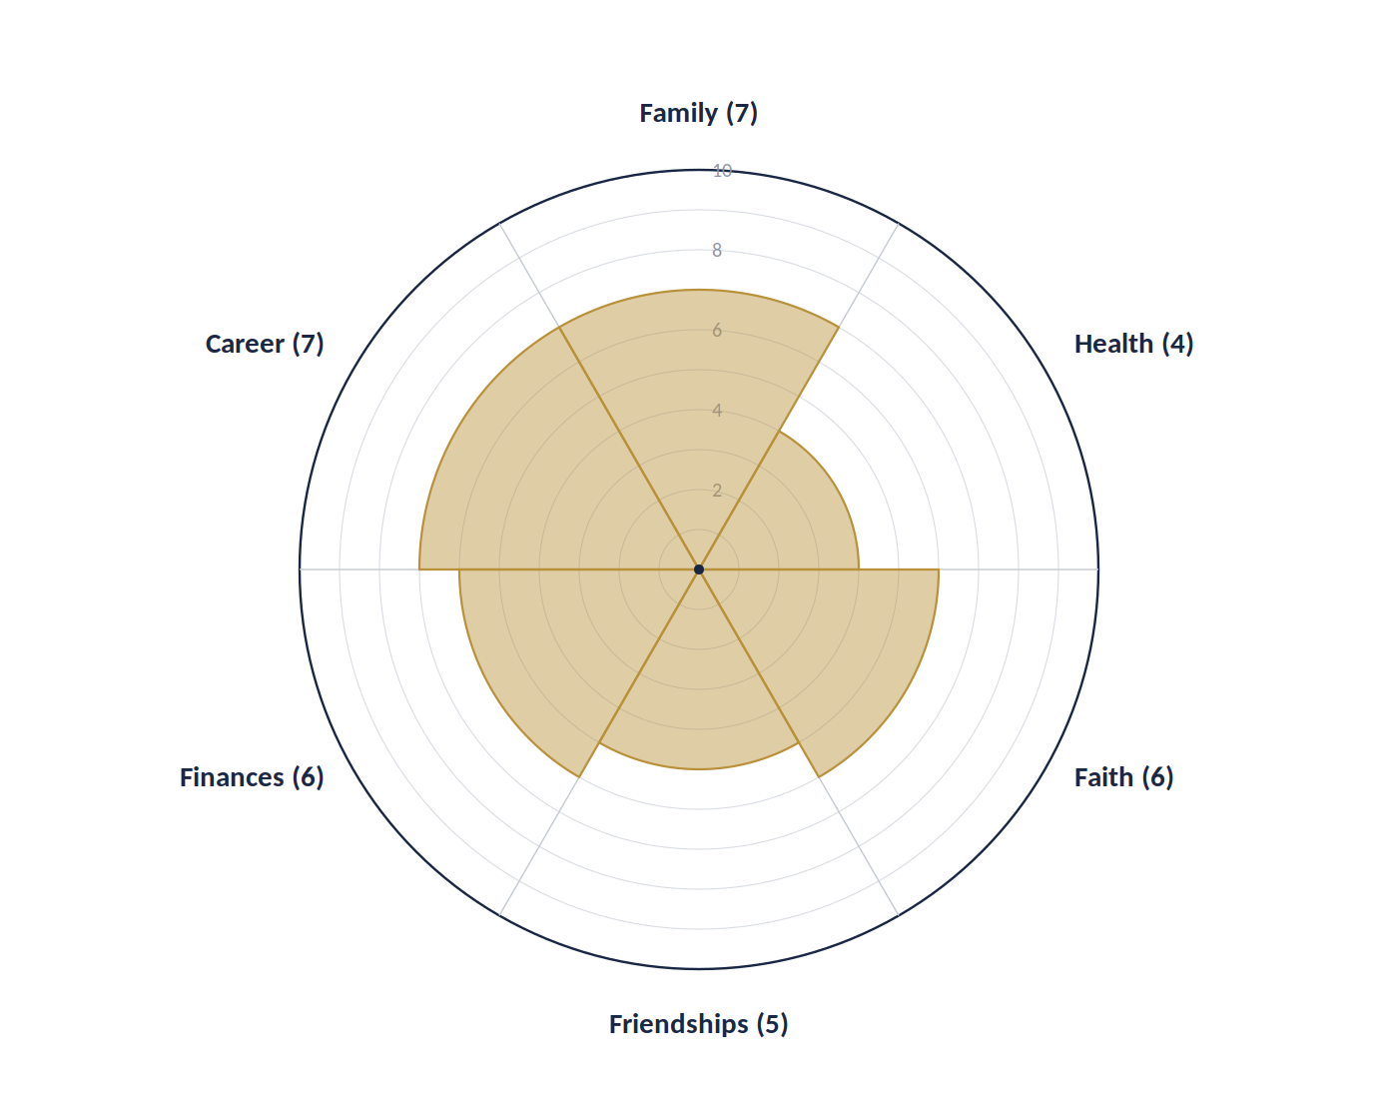
The lopsided shape calls out the lowest categories.

REFLECT ON THE GAPS
Lowest score: | Health (4 of 10)
Likely cause: | Energy. Stacked late nights, missed workouts.
Ripple effect: | Better sleep would lift Career and home life.
COMMIT TO ACTION
Focus category: | Health (raise 4 to 5 in 30 days)
One habit: | 15-min walk after lunch, 3 days/week.
One boundary: | No work messages after 7:30 pm, 2 nights/week.
Calendar blocks: | Tue 12:30 / Thu 12:30 walk; Sun 8 pm review.
COMPLETED EXAMPLE · Maria Torres, Frontline Team Lead
Here’s a career-focused wheel. Maria’s numbers look fine on the surface, but Skill Growth is the quiet drag that will catch up with her if she leaves it alone.
Your Name |  | Maria Torres |  | Role | Frontline Team Lead
WHY IT MATTERS
Performance is solid, but I’m coasting on what I already know. Skill Growth and Career Direction have stalled, and that will catch up with me.
YOUR SIX CATEGORIES · Name each one, define a 9-10, then score it
# | Category Name |  | What a 9-10 Looks Like |  |  | Score (1-10)
1 | Role Clarity |  | I know my top priorities and what success looks like this quarter. |  |  | 7
2 | Team Results |  | Team is hitting agreed targets without constant escalation. |  |  | 6
3 | Skill Growth |  | I’m building one new skill that matters in the next role. |  |  | 4
4 | Leadership Influence |  | I’m shaping decisions, not just executing other people’s calls. |  |  | 7
5 | Time & Energy |  | I end the week with capacity left, not running on fumes. |  |  | 5
6 | Career Direction |  | I have a clear next step in mind and am working toward it. |  |  | 5
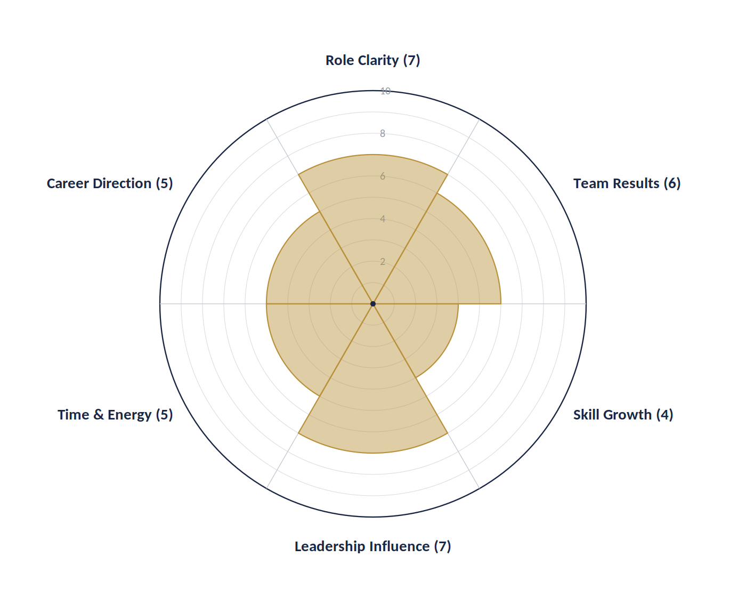
The lopsided shape calls out the lowest categories.

REFLECT ON THE GAPS
Lowest score: | Skill Growth (4 of 10)
Likely cause: | Systems. No development plan or set time.
Ripple effect: | New skill lifts Career Direction and confidence.
COMMIT TO ACTION
Focus category: | Skill Growth (raise 4 to 5 in 30 days)
One habit: | Two 45-min learning blocks, Tue and Thu.
One boundary: | No meetings before 10 am on learning days.
Calendar blocks: | Tue 8:30 / Thu 8:30 learning; Fri 4 pm review.
PAIR THIS WITH
Master Action Plan (M.A.P.)  Take your one focus category and turn it into a written 30-day plan with high-impact actions, deadlines, and a weekly review.  https://www.leadership-tools.com/master-action-plan.html |  | Leadership Assessment  Check where your leadership skills stand today across eight categories, then bring your lowest area into a plan.  https://www.leadership-tools.com/leadership-assessment.html
Pick one category. Raise it one point. Re-score in 30 to 90 days. That’s how the shape of your wheel changes.

