LEADERSHIP 360

Leadership Development Needs Assessment

A paper-and-pencil 360-degree feedback tool for assessing leadership development needs.

Survey to Assess [Insert Name of Assessee]

Introduction

Thank you for agreeing to help assess the leadership behavior of [INSERT ASSESSEE NAME]. By doing so, you will provide this fellow organizational member with valuable feedback on his/her leadership development needs. The primary goal of this program is to improve our organization’s leadership. We appreciate your assistance in performing this vital task.

We are distributing copies of this tool to this person’s superiors, subordinates, and peers for completion. By surveying up, down, and across (360 degrees), we can provide participants with information unobtainable from conventional assessment instruments. Unlike some other 360-degree instruments, this activity is anonymous – we will not ask you for any personal information, including whether you are a superior, subordinate, or peer. The authors of this tool believe that anonymity facilitates honest, objective, and user-friendly feedback. As you will note, we do not include space for written comments. The authors have observed that a single written comment often serves as a major distraction from the needs-analysis process.

Instructions

- For each behavioral scale, please circle the bullet that best reflects the behavior of [INSERT ASSESSEE NAME].

EXAMPLE:

Thinks long-term | • | • | • | • | • | Thinks short-term

In this instance, the assessor thought that the person being assessed spends somewhat more time thinking short-term than long term. If the evaluator had thought the individual being assessed spent about the same amount of time thinking short and long term, the evaluator would have circled the middle bullet. A key to successful completion of this tool is to read each behavioral scale closely and then go with your first impression. If you encounter a scale covering behavior that you have not had the opportunity to observe, simply skip that scale.

- In a sealed envelope, return the completed LEADERSHIP 360 survey form to:

[INSERT NAME /ADDRESS OF INDIVIDUAL COMPILING DATA]

Thank you for your participation!

LEADERSHIP 360 Survey

 |  | Strategy
Thinks long-term | • | • | • | • | • | Thinks short-term
Lacks a vision for her/his organization | • | • | • | • | • | Has a vision for her/his organization
Spends time setting the direction for her/his organization | • | • | • | • | • | Spends time fighting fires and resolving  crises

Communication
Is a good communicator | • | • | • | • | • | Is a poor  communicator
Is cloistered | • | • | • | • | • | Is active in the  organization
Communicates well  with other organizations | • | • | • | • | • | Communicates poorly  with other  organizations
Tends to be noncommunicative | • | • | • | • | • | Communicates  frequently

Knowledge
Has a deep-rooted understanding of the functions of her/his organization | • | • | • | • | • | Does not try to understand the functions of her/his organization
Does not understand functions of other  organizations | • | • | • | • | • | Understands functions of other organizations
Is close to the  business | • | • | • | • | • | Is not close to the business
Takes the narrow view | • | • | • | • | • | Takes the broad view

 |  | Learning
Is curious | • | • | • | • | • | Isn’t interested/doesn’t  have time
Resists change | • | • | • | • | • | Promotes change
Is a quick study | • | • | • | • | • | Is a slow, deliberate  study

Influence
Gets support | • | • | • | • | • | Fails to get support
Doesn’t know how to  sell | • | • | • | • | • | Knows how to sell
Gets people on board | • | • | • | • | • | Fails to get people on  board
Motivates people | • | • | • | • | • | Fails to motivate  people
Is dictatorial | • | • | • | • | • | Is democratic
Is unassertive | • | • | • | • | • | Is assertive

 | Relationships
Does not talk to  people | • | • | • | • | • | Talks to people
Is a good listener | • | • | • | • | • | Is a poor listener
Is good interpersonally | • | • | • | • | • | Is poor interpersonally

Relationships… continued
Is unable to deal with people | • | • | • | • | • | Is able to deal with  people
Does not interact with people enough | • | • | • | • | • | Interacts with people

 |  | Delegation
Is a good delegator | • | • | • | • | • | Is a poor delegator
Is detail-oriented | • | • | • | • | • | Is big picture-oriented
Is a nitpicker | • | • | • | • | • | Is not a nitpicker
Deals with the  important issues | • | • | • | • | • | Deals with  inconsequential detail
Is a doer | • | • | • | • | • | Is a delegator

 |  | Priorities
Is able to prioritize | • | • | • | • | • | Is unable to prioritize

 |  | Integrity
Has integrity | • | • | • | • | • | Lacks integrity
Isn’t trusted | • | • | • | • | • | Is trusted
Is overly political | • | • | • | • | • | Is political only as  needed
Takes responsibility for self | • | • | • | • | • | Blames others
Admits mistakes | • | • | • | • | • | Doesn’t admit  mistakes
Is honest, credible | • | • | • | • | • | Is dishonest, lacks  credibility

 | Confidence
Is insecure | • | • | • | • | • | Is secure
Has guts | • | • | • | • | • | Has no guts
Is unwilling to make  enemies | • | • | • | • | • | Is willing to make enemies

Confidence… continued
Is decisive | • | • | • | • | • | Is indecisive
Communicates  confidence | • | • | • | • | • | Communicates fears
Is unwilling to make  the tough decisions | • | • | • | • | • | Is willing to make the tough decisions

Please return the survey to [insert administrator’s name and address] by [insert date].

LEADERSHIP 360

Leadership Development Needs Assessment

A paper-and-pencil 360-degree tool for assessing leadership development needs.

Administrator’s Guide

Introduction

Thank you for agreeing to serve as the organizational administrator for the LEADERSHIP 360 program. By doing so, you will provide members of the organization with valuable feedback on individual leadership development needs. The primary goal of this program is to improve our organization’s leadership. We appreciate your assistance in performing this vital task.

You will be distributing copies of this tool to a participant’s superiors, subordinates, and peers for completion. By surveying up, down, and across (360 degrees), we can provide participants with information unobtainable from conventional assessment instruments. Unlike some other 360-degree instruments, this activity is anonymous – those surveyed will not be asked for any personal information, including whether they are a superior, subordinate, or peer. The authors of this tool believe that anonymity facilitates honest, objective, and user-friendly feedback. As an administrator, you play a key role in ensuring the confidentiality of results. Please treat completed forms and feedback sheets with the same confidentiality as you would with your personal records.

Instructions

- Select organizational members to be evaluated.

LEADERSHIP 360 is designed for organizational leaders and candidates for leadership positions. The behaviors evaluated are broad and generic, allowing both formal and informal leaders to participate. LEADERSHIP 360 is designed for leadership development purposes only. The authors do not endorse its use for performance appraisal or for selection purposes. Ensure that individuals to be evaluated concur with participation in this process before proceeding.

- Select evaluators.

Meet with the participant to select evaluators. The participant’s direct supervisor, all direct subordinates and peers should participate. If possible, concur with the participant on a list of 10 or more potential evaluators. Then, contact the potential evaluators to confirm their willingness to participate in the analysis.

- Distribute survey to evaluators.

Use a confidential means to distribute the survey booklets - sealed mail and in-person delivery have both been used successfully by other organizations. No matter what distribution method you use, be sure that you provide the evaluators with an easy, confidential method for returning completed surveys to you (such as a self-addressed, stamped envelope).

- Compile statistics.

Once you have received the completed forms, compile statistics using the attached scoring key (Appendix A). For the first behavior scale (Thinks long-term/Thinks short term) add up the numbers corresponding with the ratings assigned by the evaluators and then divide by the number of responses for that behavior to obtain an average score for that behavior. Record the score on the calculation worksheet (Appendix B). Repeat this process for each behavior scale on the survey. Then, calculate the average score for each leadership area (such as Strategy) by adding the average scores of the behaviors, and dividing by the number of behaviors. To calculate the overall score for LEADERSHIP 360, add the average scores for the leadership areas and divide by 10 (the number of leadership areas).

- Complete a feedback summary sheet for each participant.

Transfer the leadership area scores and overall score to the feedback sheet (Appendix C). If you are conducting several LEADERSHIP 360’s, you may want to determine average scores for your population and record them on the feedback summary sheets for comparison.

- Hold a feedback session with each participant.

Hold one-on-one feedback sessions with each LEADERSHIP 360 participant:

• Provide the participant with a quick overview of the LEADERSHIP 360 process: purpose (development); survey process; confidentiality of results, and bases for areas, behaviors, and methodology:

Kaplan, R. E. (1988) The warp and the woof of the general manager’s job. In F. Schoorman, and B. Schneider (eds.), Facilitating work effectiveness. Lexington, MA: Lexington Books. (a seminal piece on effective executive behavior - the source of executive leadership areas and most behaviors in LEADERSHIP 360 )

Keeley, W. A. (1997) Management training and development needs analysis. Carlsbad, NM : U.S. Department of Energy Carlsbad Area Office. (the LEADERSHIP 360 needs analysis approach evolved from this assessment tool)

Keeley, W. A. (1997 - unpublished) Field test notes for LEADERSHIP 360.
Carlsbad, NM . (the norming data in Appendix C. came from these notes)

- Review the leadership areas, behaviors, and scoring, using Appendix A. Be sure the participant understands the scoring process. Note: retain Appendix A after review

- Review completed Appendices B and C with the participant. Allow the participant plenty of time to consider the results and ask questions. Then ask the participant how she or he can use the information to improve her/his leadership. Note: Give the participant Appendices B and C to keep.

- Ask the participant and evaluators for feedback on LEADERSHIP 360

- Place a reminder of the calendar to re-take the LEADERSHIP 360 a year in the future for the purpose of measuring improvement.

Appendix A

LEADERSHIP 360 Scoring Key

 |  | Strategy
Thinks long-term | 5 | 4 | 3 | 2 | 1 | Thinks short-term
Lacks a vision for her/his organization | 1 | 2 | 3 | 4 | 5 | Has a vision for her/his organization
Spends time setting the direction for her/his organization | 5 | 4 | 3 | 2 | 1 | Spends time fighting fires and resolving  crises

 | Communication
Is a good communicator | 5 | 4 | 3 | 2 | 1 | Is a poor  communicator
Is cloistered | 1 | 2 | 3 | 4 | 5 | Is out and about in the organization
Communicates well  with other organizations | 5 | 4 | 3 | 2 | 1 | Communicates poorly  with other  organizations
Tends to be noncommunicative | 1 | 2 | 3 | 4 | 5 | Communicates  frequently
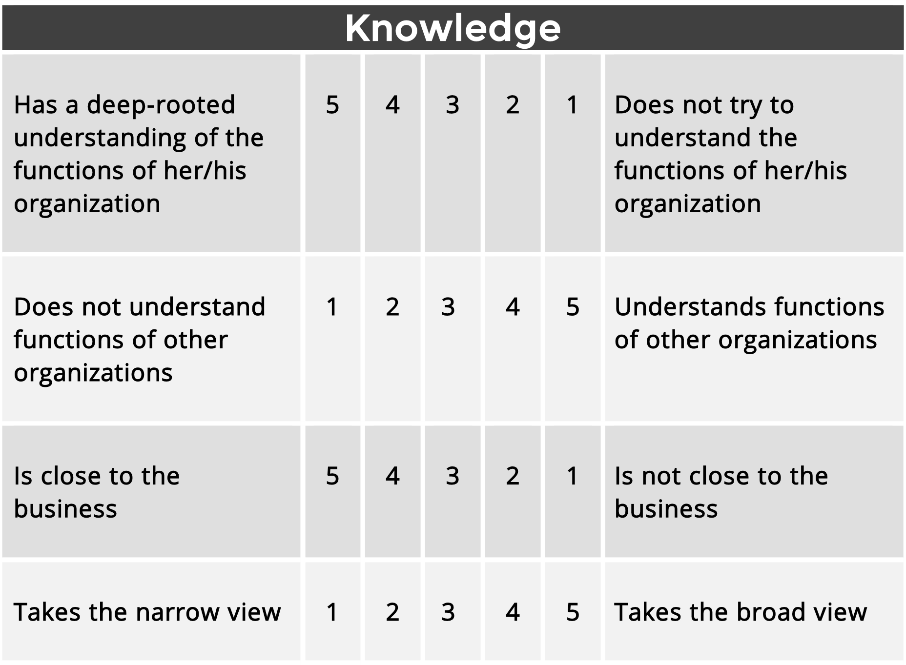

 |  | Learning
Is curious | 5 | 4 | 3 | 2 | 1 | Isn’t interested/doesn’t  have time
Resists change | 1 | 2 | 3 | 4 | 5 | Promotes change
Is a quick study | 5 | 4 | 3 | 2 | 1 | Is a slow, deliberate  study

 |  | Influence
Gets support | 5 | 4 | 3 | 2 | 1 | Fails to get support
Doesn’t know how to  sell | 1 | 2 | 3 | 4 | 5 | Knows how to sell
Gets people on board | 5 | 4 | 3 | 2 | 1 | Fails to get people on  board
Motivates people | 5 | 4 | 3 | 2 | 1 | Fails to motivate  people
Is dictatorial | 1 | 2 | 3 | 4 | 5 | Is democratic
Is unassertive | 1 | 2 | 3 | 4 | 5 | Is assertive

 | Relationships
Does not talk to  people | 1 | 2 | 3 | 4 | 5 | Talks to people
Is a good listener | 5 | 4 | 3 | 2 | 1 | Is a poor listener
Is good interpersonally | 5 | 4 | 3 | 2 | 1 | Is poor interpersonally
Relationships… continued
Is unable to deal with people | 1 | 2 | 3 | 4 | 5 | Is able to deal with  people
Does not interact with people enough | 1 | 2 | 3 | 4 | 5 | Interacts with people

 |  | Delegation
Is a good delegator | 5 | 4 | 3 | 2 | 1 | Is a poor delegator
Is detail-oriented | 1 | 2 | 3 | 4 | 5 | Is big picture-oriented
Is a nitpicker | 1 | 2 | 3 | 4 | 5 | Is not a nitpicker
Deals with the important issues | 5 | 4 | 3 | 2 | 1 | Deals with  inconsequential detail
Is a doer | 1 | 2 | 3 | 4 | 5 | Is a delegator

 |  | Priorities
Is able to prioritize | 5 | 4 | 3 | 2 | 1 | Is unable to prioritize

 |  | Integrity
Has integrity | 5 | 4 | 3 | 2 | 1 | Lacks integrity
Isn’t trusted | 1 | 2 | 3 | 4 | 5 | Is trusted
Is overly political | 1 | 2 | 3 | 4 | 5 | Is political only as needed
Takes responsibility for self | 5 | 4 | 3 | 2 | 1 | Blames others
Admits mistakes | 5 | 4 | 3 | 2 | 1 | Doesn’t admit  mistakes
Is honest, credible | 5 | 4 | 3 | 2 | 1 | Is dishonest, lacks  credibility

 | Confidence
Is insecure | 1 | 2 | 3 | 4 | 5 | Is secure
Has guts | 5 | 4 | 3 | 2 | 1 | Has no guts
Is unwilling to make enemies | 1 | 2 | 3 | 4 | 5 | Is willing to make  enemies
Confidence… continued
Is decisive | 5 | 4 | 3 | 2 | 1 | Is indecisive
Communicates  confidence | 5 | 4 | 3 | 2 | 1 | Communicates fears
Is unwilling to make the tough decisions | 1 | 2 | 3 | 4 | 5 | Is willing to make the  tough decisions

Appendix B

LEADERSHIP 360 Calculation Worksheet

Area/Behavior  (Positive behaviors are in bold) | Average Score | Behavior

Strategy
Thinks long-term | _______ | Thinks short-term
Lacks a vision for her/his organization | _______ | Has a vision for her/his organization
Spends time setting the direction for her/his. . . | _______ | Spends time fighting fires . . .
Add average scores for the 3 Strategy behaviors: | _______ | Divide by 3 = ________  Strategy Score

Communication
Is a good communicator | _______ | Is a poor communicator
Is cloistered | _______ | Is out and about in the organization
Communicates well with other organizations | _______ | Communicates poorly with other organizations
Tends to be non-communicative | _______ | Communicates frequently
Add average scores for the 4 Communications behaviors: | _______ | Divide by 4 = ________  Communications Score

Knowledge
Has a deep-rooted understanding of the functions of her/his organization | _______ | Does not try to understand the functions of her/his organization
Does not understand functions of other organizations | _______ | Understands functions of other organizations
Is close to the business | _______ | Is not close to the business
Takes the narrow view | _______ | Takes the broad view
Add average scores for the 4 Knowledge behaviors: | _______ | Divide by 4 = ________  Knowledge Score

Learning
Is curious | _______ | Isn’t interested/doesn’t have time
Resists change | _______ | Promotes change
Is a quick study | _______ | Is a slow, deliberate study
Add average scores for the 3 Learning behaviors: | _______ | Divide by 3 = ________  Learning Score

Influence
Gets support | _______ | Fails to get support
Doesn’t know how to sell | _______ | Knows how to sell
Gets people on board | _______ | Fails to get people on board
Motivates people | _______ | Fails to motivate people
Is dictatorial | _______ | Is democratic
Is unassertive | _______ | Is assertive
Add average scores for the 6 Influence behaviors: | _______ | Divide by 6 = ________  Influence Score

Relationships
Does not talk to people | _______ | Talks to people
Is a good listener | _______ | Is a poor listener
Is good interpersonally | _______ | Is poor interpersonally
Is unable to deal with people | _______ | Is able to deal with people
Does not interact with people enough | _______ | Interacts with people
Add average scores for the 5 Relationships behaviors | _______ | Divide by 5= ________  Relationships score

Delegation
Is a good delegator | _______ | Is a poor delegator
Is detail-oriented | _______ | Is big picture-oriented
Is a nitpicker | _______ | Is not a nitpicker
Deals with the important issues | _______ | Deals with inconsequential detail
Is a doer | _______ | Is a delegator
Add average scores for the 5 Delegation behaviors: | _______ | Divide by 5 = ________  Delegation Score

Priorities
Is able to prioritize | _______ | Is unable to prioritize
Add average scores for the 1 Priorities behavior: | _______ | Divide by 1 = ________  Priorities Score

Integrity
Has integrity | _______ | Lacks integrity
Isn’t trusted | _______ | Is trusted
Is overly political | _______ | Is political only as needed
Takes responsibility for self | _______ | Blames others
Admits mistakes | _______ | Doesn’t admit mistakes
Is honest, credible | _______ | Is dishonest, lacks credibility
Add average scores for the 6 Integrity behavior: | _______ | Divide by 6 = ________  Integrity Score

Confidence
Is insecure | _______ | Is secure
Has guts | _______ | Has no guts
Is unwilling to make enemies | _______ | Is willing to make enemies
Is decisive | _______ | Is indecisive
Communicates confidence | _______ | Communicates fears
Is unwilling to make the tough decisions | _______ | Is willing to make the tough decisions
Add average scores for the 6 Confidence behavior: | _______ | Divide by 6 = ________  Confidence Score
Add average scores for the 10 leadership areas: ___________
Divide by 10 = ___________
Overall Leadership Score

Appendix C

LEADERSHIP 360 Feedback Summary Sheet

Leadership Area | Your score | Norming Group Average Score*
Strategy | _______ | 3.33
Communication | _______ | 3.50
Knowledge | _______ | 4.50
Learning | _______ | 4.00
Influence | _______ | 4.00
Relationships | _______ | 4.00
Delegation | _______ | 3.70
Priorities | _______ | 4.00
Integrity | _______ | 3.11
Confidence | _______ | 3.78
Overall | _______ | 3.79
*From Keeley, W. A. (1997 - unpublished) Field test notes for LEADERSHIP 360. N = 30

